AC VOLTAGE SENSOR FOR 3-PHASE NPC MULTI LEVEL INVERTER

YADURAJ SINGH TOMAR(231040124)

AAYUSH CHAUDHARI(231040001)

M.TECH - POWER ENGINEERING

REPORT AND CALCULATIONS :

* Supply voltage for AC Voltage Sensor = 3.3V
* Used voltage divider circuit to get 1.65Volt ( 3.3/2) to supply at non inverting node of AD8608
* Input pulse of (-900V to +900V ) is applied at inverting mode of AD8608 Opamp
* **Feedback Resistance (R7 , R5 ) calculation** :

R7 , R5 should be taken such that Vout is less than 3.3 Volt

Rinput = 1M+1M+1M+1K=3001K

Vin pulsed = 900+900=1800V

R7,R5 = (3.3÷1800)*3001 =5.5k

We have taken R7,R5 = 3.92k for our convenience and safety

LT SPICE MODEL :

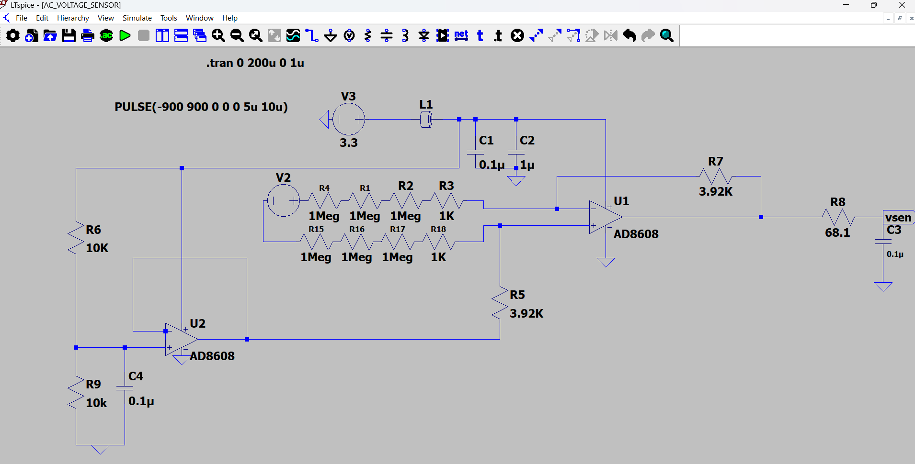

Waveforms :

V_sen

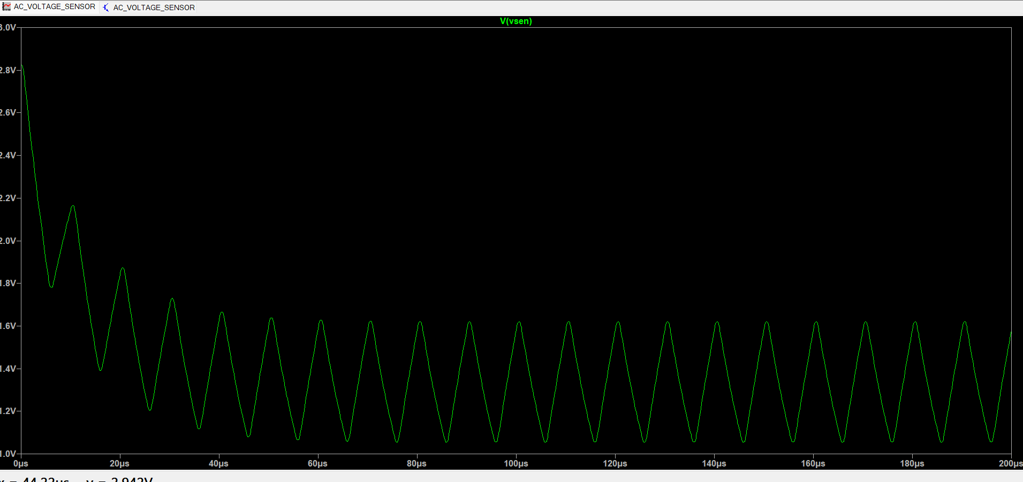

Components Used with ratings :

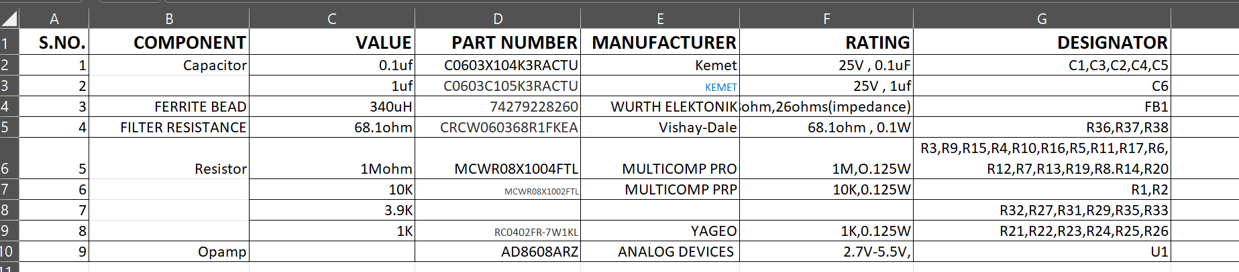

Bill Of Material of Components used :

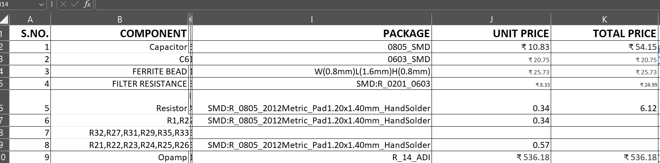

Kicad Schematic :

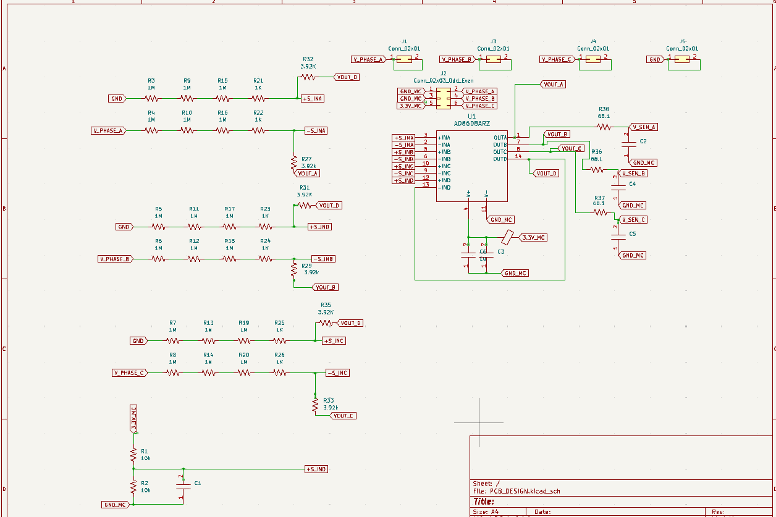

Kicad PCB Design :

Front

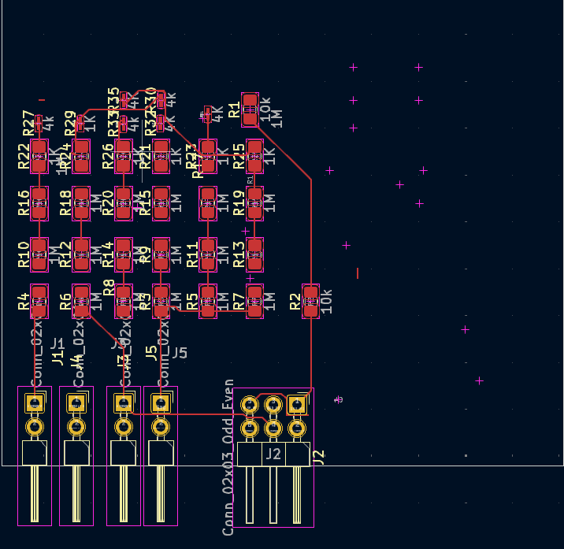

Back:

